**Case Study Project for EDA(Exploratory Data Analysis**)

**Case Study 1:**

1. **Female users tend to have significantly larger friend networks than Male users.**

**Case Study 2:**

1. **How many times of the more friends does the average female users have than the male users?**

**Case Study 3:**

1. **Users accumulate more friends over years using the years they joined.**

**Case Study 1:**

Created a box plot for each gender with the function of y as mean.

ggplot(aes(x = gender, y = age),

data = subset(pf, !is.na(gender))) + geom_boxplot() +

stat_summary(fun.y =mean , geom = 'point' , shape = 4)

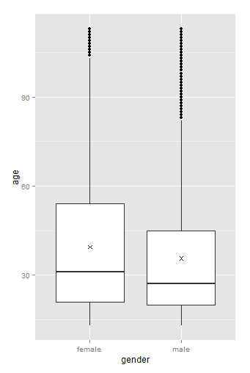

Where x shows the average of each gender count since we used the shape = 4.

*Quite interesting observation I found is ,*

***Male users are younger compared to female users.***

But this plot doesn’t capture the substantial difference in friend count.

So I created the same plot as a function of y as median.

ggplot(aes(x = age, y = friend_count),

data = subset(pf, !is.na(gender))) +

geom_line(aes(color = gender), stat = 'summary' , fun.y =median )

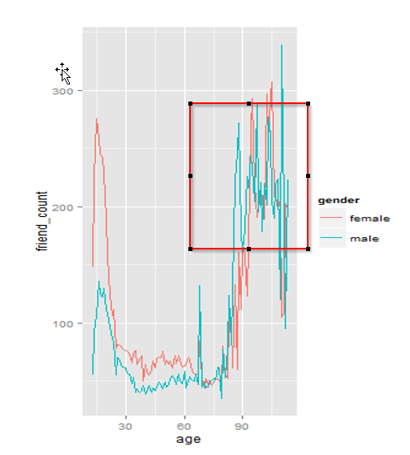 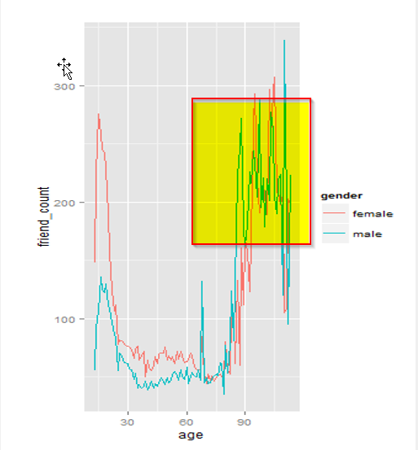

***Observation:***

This plot gave me an idea as median count for female friends count are larger than male users.

*At the age 70 both the male and female users have more or less the same size of friend count regardless of the gender.*

*Gender difference is larger at the young age.*

Since the older age (yellow highlighted area) has noisy distribution, I thought of reproduce the plot using the summary of data with Dplyr package.

**Case Study 3:**

Created new data frame called pf.fc_by_age_gender.

pf.fc_by_age_gender <- pf %>%

group_by(age, gender) %>%

summarise(mean_friend_count = mean(friend_count),

median_friend_count = median(friend_count),

n= n()) %>%

ungroup() %>%

arrange(age)

How many times of the more friends does the average female users have than the male users?

Right now our data has long format with repeating ages.

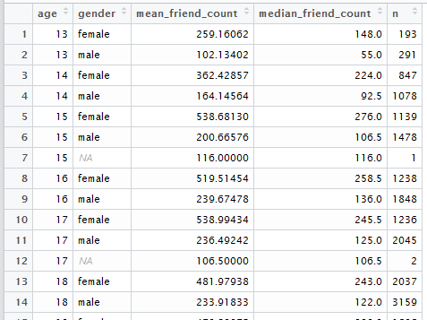

I need to reshape the data by removing duplicates using reshape2 package.

Created new data frame using dcast pf.fc_by_age_gender.wide

pf.fc_by_age_gender.wide <- dcast(pf.fc_by_age_gender,

age ~ gender ,

value.var = 'median_friend_count')

head(pf.fc_by_age_gender.wide)

To find the ration plot,

ggplot(aes(x = age, y = female / male),

data = pf.fc_by_age_gender.wide) +

geom_line() +

geom_hline(yintercept = 1, alpha = 0.3 , linetype = 2)

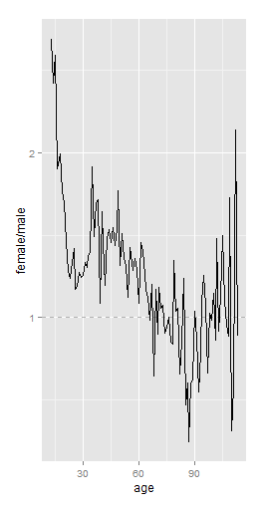

***I can see very young users than the median female users has over 2 and ½ times as many friends as the median of male users.***

I am able to visualize now with the condition of age with the relationship of friend’s count and gender.

**Case Study 3:**

Users accumulate more friends over years using the years they joined.

One way to explore is age , gender and the alpha variable or

Tenure is the good way to use.

pf$year_joined <- floor(2014 - pf$tenure/365)

pf$year_joined.bucket <- cut(pf$year_joined,

c(2004,2009,2011,2012,2014))

At this point New column with the name year_joined has been added to pf data frame.

Created a variable name called year_joined based on Tenure variable and converted this variable to year_joined_bucket based .

ggplot(aes(x = age, y = friend_count),

data = subset(pf, !is.na(year_joined.bucket))) +

geom_line(aes(color = year_joined.bucket), stat = 'summary' , fun.y =median )

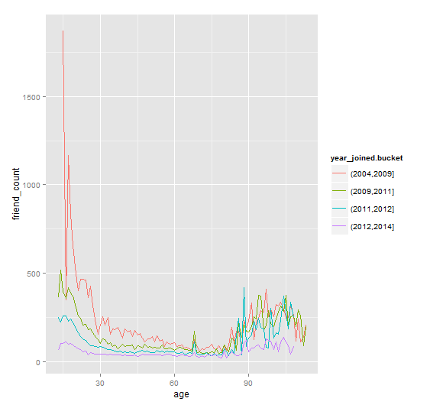

Observation:

The above examination across friend count and age split up by year_joined.bucket.

My assumptions are confirmed by look at this plot.

Longer tenure has the higher rate of friends count with the exception of older age of 80 and above.